1) We can convert biomass materials into __i__ and blend them with gasoline and diesel for transportation. Large scale replacement of fossil fuels for this purpose likely won’t happen because __ii__.
The statements above are completed correctly by the information in row ____.
Select one:
a. additives; the combined process has a high power density.
b. biofuels; the combined process has a high power density
c. additives; the combined process has a low power density
d. biofuels; the combined process has a low power density

2) Biomass generation is controversial in some parts of the world because __i__. The controversy can be reduced by __ii__.

The statements above are completed correctly by the information in row ____.
Select one:
a. no crops grow there; irrigating the land
b. no crops grow there; using agriculture waste
c. food crops are used; irrigating the land
d. food crops are used; using agriculture waste

Use the graph to answer numbers number 3 and 4

3) The energy transformations in a wind turbine, from the sun’s energy to producing electricity are, in order a, b, c.
The values of a, b, and c, respectively, are solar, Kinetic, nuclear

4) The energy transformations in a solar cell, from the sun’s energy to producing electricity are, in order a, b.
The values of a and b, respectively, are Solar, electric
5) The biggest drawback to extensive use of photovoltaic cells is
Select one:
a. they produce DC electricity.
b. they don’t work well in cold climates.
c. they are expensive to manufacture.
d. they kill bats and birds.

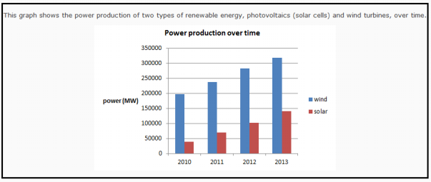

6) The reason there is more electric production by wind is that
Select one:
a. wind energy started sooner than solar cells.
b. it’s easier to design for wind energy.
c. there are more ideal sites for wind turbines than for solar cells.
d. wind turbines are easier to maintain than are solar cells.

Use graph to answer questions
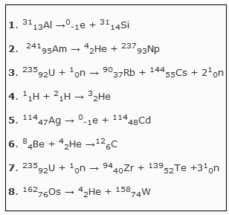
7) The reactions that represent alpha decays are
(you may select more than one answer)
Select one or more:
a. 1
b. 2
c. 3
d. 4
e. 5
f. 6
g. 7
h. 8

8) The reactions that represent beta decays are
(you may select more than one answer)
Select one or more:
a. 1
b. 2
c. 3
d. 4
e. 5
f. 6
g. 7
h. 8

9) The fusion reactions are
(you may select more than one answer)
Select one or more:
a. 1
b. 2
c. 3
d. 4
e. 5
f. 6
g. 7
h. 8

10) The fission reactions are
(you may select more than one answer)
Select one or more:
a. 1
b. 2
c. 3
d. 4
e. 5
f. 6
g. 7
h. 8

11) Some nuclear reactions are exothermic and some are endothermic. In an endothermic reaction the total mass of the products will be __i__ than the mass of the reactants because __ii__.

The statements above are completed correctly by the information in row ____.
Select one:
a. greater than; mass was converted into energy
b. greater than; energy was converted into mass
c. less than; mass was converted into energy
d. less than; energy was converted into mass

12) The energy produced when 40 g of matter is converted to energy in a nuclear reaction is a.b×10cd J.

The values of a, b, c, and d are
E = mc²
= (0.040 kg)(3.00×10^8 m/s)² = 3.6×10^15 J

13) When a uranium atoms splits in two, a few stray neutrons are produced. If these neutrons can induce the splitting of more uranium atoms, a chain reaction results. In order to facilitate this, a nuclear reactor contains __i__which slows the neutrons down. __ii__ is/are used to determine how many of these stray neutrons can continue the chain reaction.

The statements above are completed correctly by the information in row ____.
Select one:
a. a decelerator; A callandria
b. a moderator; A callandria
c. a decelerator; Control rods
d. a moderator; Control rods

14) The energy transformations that take place within a nuclear reactor are
Select one:
a. nuclear to thermal to electrical
b. thermal to nuclear to kinetic to electrical
c. nuclear to thermal to kinetic to electrical
d. thermal to nuclear to thermal to kinetic to electrical

15) In a CANDU nuclear reactor, __i__ in a process known as __ii__.

The statement above is completed correctly by the information in row ____.
Select one:
a. small nuclei are joined together; nuclear fission
b. large nuclei are split apart; nuclear fission
c. small nuclei are joined together; nuclear fusion
d. large nuclei are split apart; nuclear fusion

16) Most of the geothermal heat we use comes from __i__. The best places on earth to take advantage of geothermal energy are __ii__.

The statements above are completed correctly by the information in row ___.
Select one:
a. radioactive decay; volcanic areas
b. radioactive decay; mountainous areas
c. natural cooling of the Earth; volcanic areas
d. natural cooling of the Earth; mountainous areas

17) A good location for a power station is near a population centre because __i__ and near a source of fuel because __ii__.

The statement above is completed correctly by the information in row ____.
Select one:
a. commuting to work is easier; transportation costs are lower
b. the customers are nearby; transportation costs are lower
c. commuting to work is easier; it's easier to turn raw material into fuel
d. the customers are nearby; it's easier to turn raw material into fuel

Use this graph to answer number 18
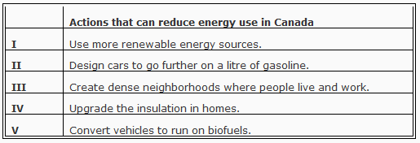
18) The actions listed above which would reduce energy used by Canadians are
Select one:
a. all of them
b. I, II, and V only
c. II, III, and IV only
d. II and IV only

19) One way to reduce our ecological footprint without giving up our standard of living is to use solar energy in our houses. Large windows facing south in a room with a concrete floor are examples of __i__. Solar thermal cells on the roof with tubes circulating heat into the house is an example of __ii__.

The statements above are completed correctly by the information in row ____.
Select one:
a. passive solar heating; active solar heating
b. passive solar heating; passive solar heating
c. active solar heating; active solar heating
d. active solar heating; passive solar heating

Use the graph and info answer number 20
There isn't enough arable land to completely replace fossil fuels with biomass fuels and still be able to feed the population. One controversy arises when food crops like corn are grown and used as biofuel. People are starving even though there is enough food to feed them. Is it ethical to burn food when people are starving? We can, however, use marginal land for non-food crops and use the waste materials to make the biofuels. At about 15% of total energy production, Canada lags behind Europe in biomass energy production, but there is lots of growth potential.
Some countries are enacting regulatory initiatives that promote the use of biomass technologies.
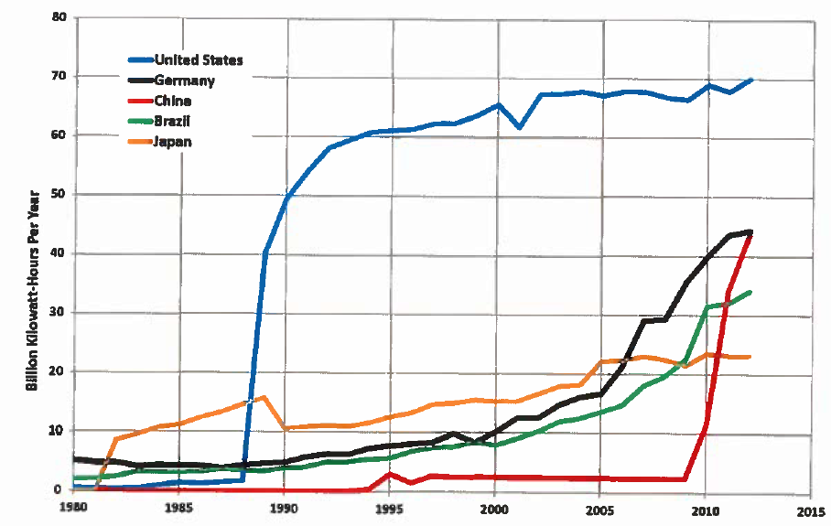

20) We might conclude from this graph that
Select one:
a. A new discovery was made in the United States before it was made in China.
b. All countries will eventually produce the same amount of energy from biomass.
c. Government regulation is an effective way to jumpstart a new technology.
d. A new technology can’t start in a country until the infrastructure is just right.

Use this pic to answer number 21
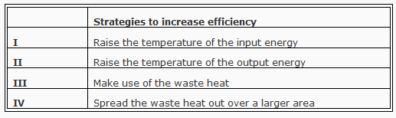

21) Strategies listed that would improve efficiencies include
Select one:
a. I and II only
b. I, II, and III only
c. II and IV only
d. I and III only

Use this pic to answer 22
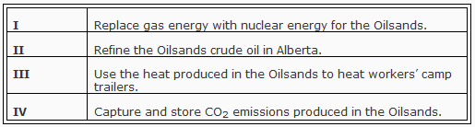
22) The ideas that would increase the efficiency of the Oilsands and might be implemented are
Select one:
a. I and IV only
b. II, III, and IV only
c. III only
d. III and IV only

23) Reducing the size of the combustion particles in a thermal plant __i__ of the combustion process. Burning in low oxygen can produce __ii__.

The statement above is completed correctly by the information in row ___.
Select one:
a. decreases temperature; syngas
b. increase in efficiency; syngas
c. decreases the temperature; more particulates
d. increases the efficiency; more particulates

24) As a fuel, hydrogen seems ideal. During combustion it has no __i__emissions, however, it presents special problems with __ii__.
The statement above is completed correctly by the information in row ____.
Select one:
a. carbon dioxide; storage and transportation
b. carbon dioxide; low energy density
c. thermal; storage and transporation
d. thermal; low energy density

25) In order to produce hydrogen without greenhouse gas emissions, we must use __i__ with electricity produced by __i__.
The statement above is completed correctly by the information in row ____.
Select one:
a. natural gas reforming; methane combustion
b. natrual gas reforming; wind turbines
c. electrolysis; methane combustion
d. electrolysis; wind turbines

26) One way of using energy from hydrogen involves using it in a __i__. The major drawback to this technology is __ii__.

The statements above are completed correctly by the information in row ____.
Select one:
a. fuel cell; the high cost
b. fuel cell; a network of fuel stations
c. liquid form; the high cost
d. liquid form; a network of fuel stations

27) The combined fission fusion nuclear reactor could be efficient enough to __i__and could also be used to __ii__ .

The statement above is completed correctly by the information in row ____.
Select one:
a. supply nearly endless energy; use up our radioactive wastes
b. supply nearly endless energy; produce hydrogen for cars
c. generate electricity economically; use up our radioactive wastes
d. generate electricity economically; produce hydrogen for cars

28) There are many people who don’t believe that clean coal will ever be a reality. Of all the fossil fuels, coal has the highest greenhouse gas emissions, primarily carbon dioxide. The best solution we know of for this problem is __i__ but doing this would __ii__.

The statements above are completed correctly by the information in row ____.
Select one:
a. capturing and storing the carbon dioxide; increase costs by reducing the efficiency of the plant
b. converting the coal to natural gas; increase costs by reducing the efficiency of the plant
c. capturing and storing the carbon dioxide; decrease costs but increase other wastes
d. converting the coal to natural gas; decrease costs but increase other wastes

Use this info to answer number 29

Several US and Canadian companies have developed processes that deal with carbon dioxide in a novel way.
A US company passes the CO 2 emissions from a power plant through seawater where it reacts to form calcium carbonate which can be used to make cement. (Cement is one ingredient used to make concrete.)
A Halifax based company has a process that injects CO2 from power plants into concrete blocks in a way that prevents the blocks from releasing the CO2 over time.

29) Both of these processes are examples of ___i___ and increase efficiency by __ii__.
The statement above is completed correctly by the information in row ____.
Select one:
a. using renewable energy; using less energy
b. using renewable energy; using waste material
c. carbon capture and storage; using less energy
d. carbon capture and storage; using waste material

